From Friction to Flow: Solutions That Make a Difference
Every organization has people. And wherever there are people, there are different personalities, communication styles, and ways of working.
I help leaders and teams better understand human behavior, navigate differences, and strengthen workplace relationships through engaging, interactive learning experiences.
Explore how we can work together.
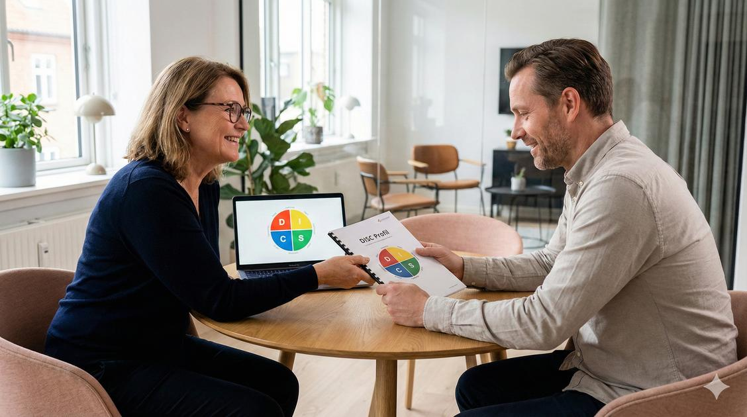
DISC Assessments & Debriefs
Build greater self-awareness, understand behavioral differences, and reduce misunderstandings that create workplace friction.
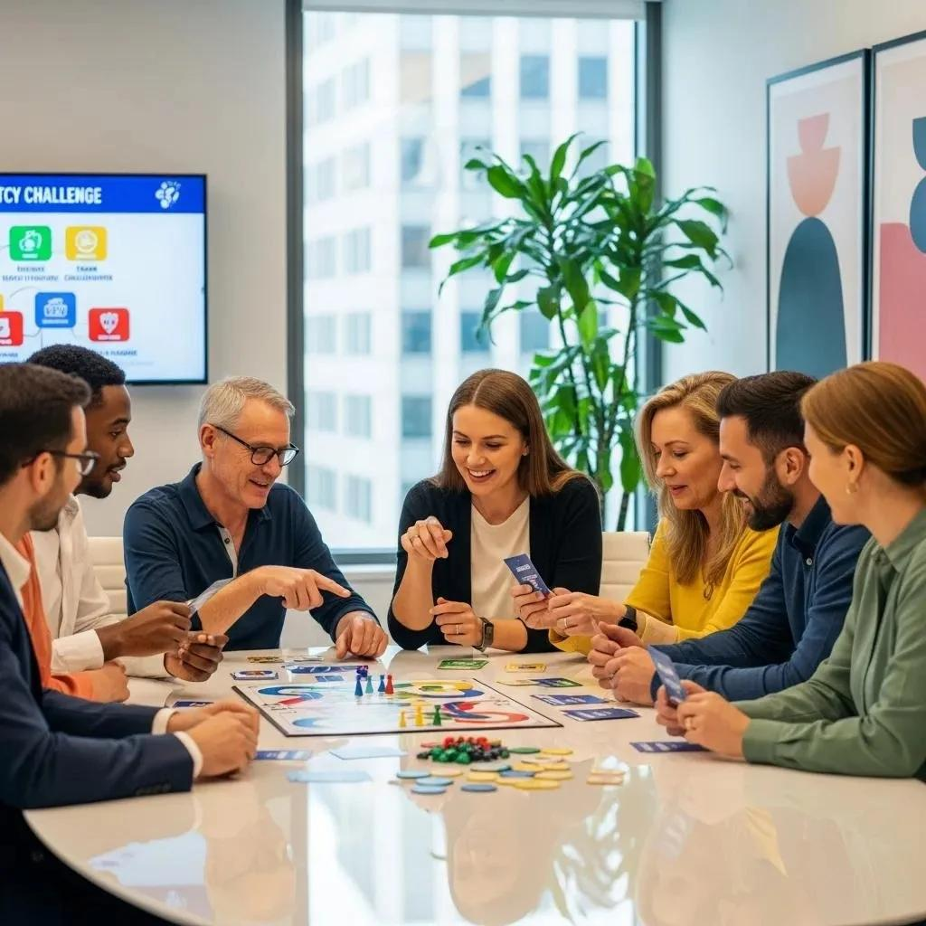
The Leadership Game Experience
Strengthen team connections, spark meaningful leadership conversations, and uncover opportunities for individual and collective growth.
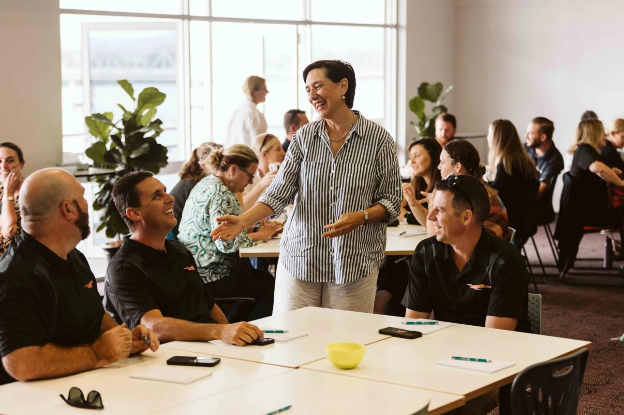
From Friction to Flow Workshops
Transform communication challenges into opportunities for stronger collaboration, greater understanding, and more effective teamwork.
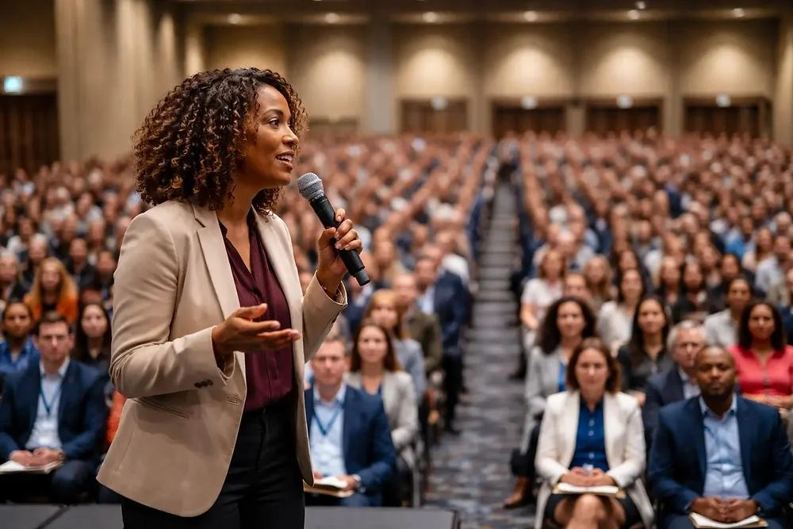
Keynotes & Speaking Engagements
Inspire audiences with fresh perspectives, relatable stories, and practical strategies they can put into action immediately.
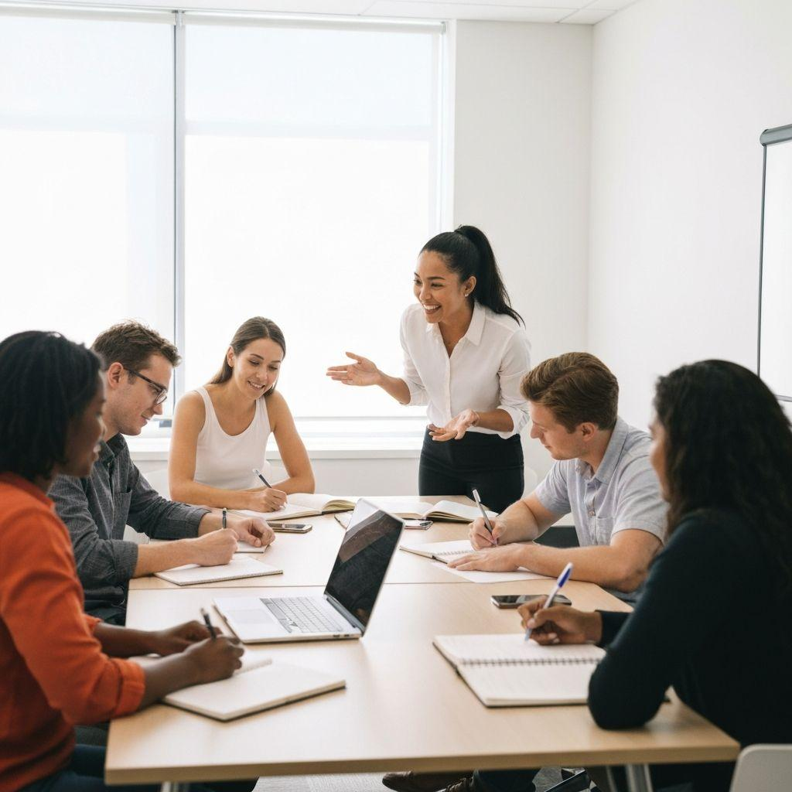
Customized Team Development
Create stronger communication, build trust, and improve team effectiveness through experiences designed around your organization's unique needs.
Finish with a call to action
Ready to Move From Friction to Flow?
Let's explore what's happening within your team and identify an experience that will help you move forward.

